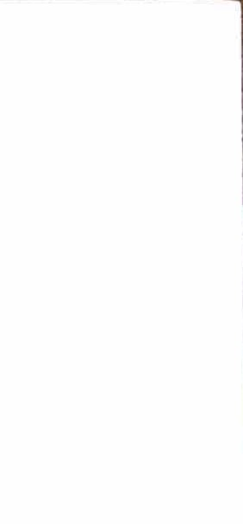


MARDI GRAS PARADE IN MILLBROOK SATURDAY, February 7, 2026 AT NOON
Mardi Gras Season in Millbrook this year is (February 7, 2026) and this is your invitation to come join 1lS for afun time by enteringthe parade:- A parade entry form and additional information about---thc parade is~ enclosed. We take pride in the fact that there is no entry fee for your participation.

As in the past, the main assembly area is at Mill Creek Baseball Park at the end of Shirley Lane behind the Smokehouse Restaurant. A secondary assembly area is alongside the Dollar General in Southgate Plaza on Main Street, just across from the Smokehouse. After receiving your application, we will send you an email giving you your assembly area. We will have workers to direct you to your place in the parade. The parade ends at Millbrook Shopping Center (where Climate Control Storage is located) on the left side (west) of Main Street. The parade distance is right at one mile.
If you can join us in the parade please complete the enclosed entry form and return it as soon as possible by mailing to: Keith Yarbrough, 1806 Autumn Ct W, Prattville, AL 36066.

If you wish to order throws from us please complete the enclosed Order Form and mail it, with a check by January 10, 2026 payable to the Millbrook Revelers, to Glenda Yarbrough at 1806 Autumn Ct. W. Prattville, AL 36066.
All details about the Festival and Parade, including how to buy 'Throws" at a reasonable price, and vendor information can be found on our web site at: www.millbrookrevelers.org. Vendors need to call CharJes Prevel at 520-482-8454 for infonnation on becoming a vendor.

You can be of tremendous help by simply mentioning this event to your friends, family and neighbors.

REMEMBER-DETAILED INFORMATION IS AVAILABLE ON OUR WEB SITE:
WWW.MILLBROOKREVELERS.ORG. If I can help you in any way feel free to call me at (334) 318-0039 (Cell) or 361-1074 (Home)

Let the Good Times Roll,

Keith Yarbrough Parade - Chairman

